Organizational Change

2. What are the fundamental dimensions of change?

Organizations are constantly evolving. One common refrain is that "there is nothing so constant as

change." Because of this, there is no one best way to organize in all circumstances. Effective managers need to

be aware of the various factors that drive the need for change.

Contents:

1. Types of change in organizations
2. Organizational life cycle model
3. Dimensions of change

1)Types of Change

* Structural change.
  + changes in the overall formal relationships within an organization.
  + Examples of structural change include reorganizing departments or business units,

adding employee positions, or revising job roles and assignments.

* + These changes should be made to support broader objectives such as to centralize or decentralize operations, empower employees, or find greater efficiencies.
* Technological Change
  + Implementation of new technologies is often forced upon an organization as the environment shifts.
  + For example, an industry upgrade in a commonly used software platform may require that employees learn new ways of working.
* Culture Change
  + Organizational culture refers to the common patterns of thinking and behaving within an organization.
  + Culture change is among the most difficult kinds of changes to create within an organizational system.
  + A typical culture change process, if it is successful, requires many years to achieve.

2)The organizational life cycle

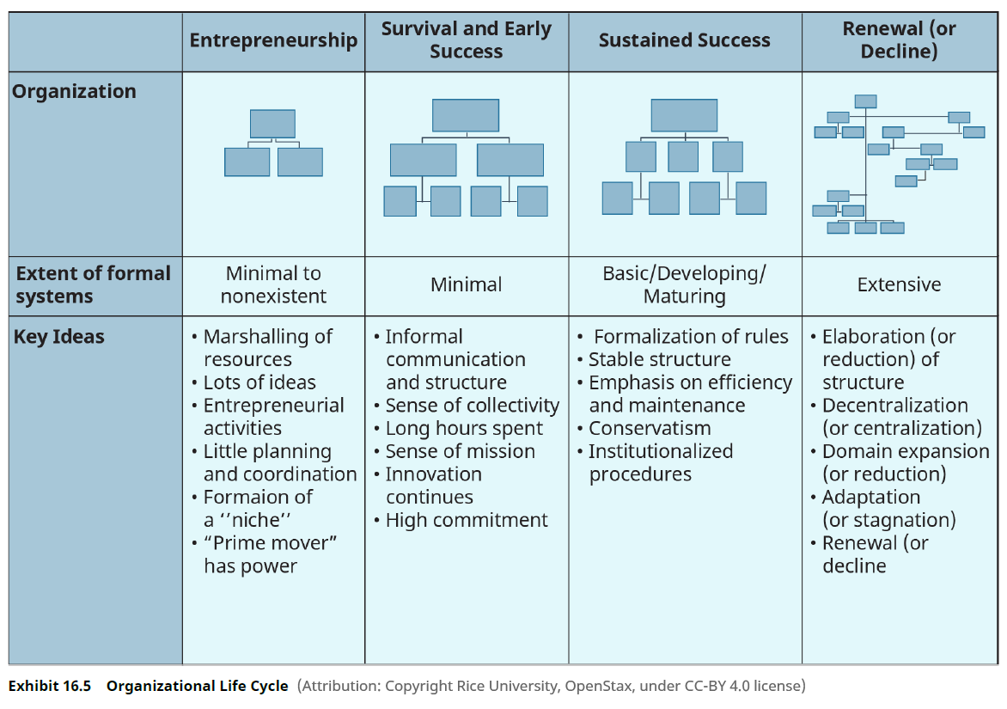

3)Dimensions of Change

Dimensions of Change

When considering how to assess the need for change in an organization, it can be helpful to think of three

dimensions: the scope of change, the level of change, and the intentionality of change.

The first, the **scope of change** refers to the degree to which the required change will disrupt current patterns

and routines. **Incremental change** refers to small refinements in current organizational practices or routines

that do not challenge, but rather build on or improve, existing aspects and practices within the organization.

Common incremental change practices are LEAN and Six Sigma, which are used to find relatively small

changes that can generate greater efficiencies in a process. An organization can improve its product-line

efficiencies by identifying small discrepancies in process, then fixing them in a systematic way. Incremental

change does not typically challenge people to be at the edge of their comfort zone. (Setter, Craig Joseph and The Council for Six Sigma Certification, *Six Sigma: A Complete Step-by-Step Guide*, The

Council for Six Sigma Certification, 2018.)

In contrast, **transformational change** refers to significant shifts in an organizational system that may cause

significant disruption to some underlying aspect of the organization, its processes, or structures.

Transformational change can be invigorating for some employees, but also highly disruptive and stressful for

others. Examples of transformational change include large systems changes and organizational restructuring.

Culture change often requires transformational change to be successful.( Eisenbach, R., Watson, K., and Pillai, R., “Transformational Leadership in the Context of Organizational

Change”, *Journal of Organizational Change Management*, 12, 1999, pp. 80-89.)

Finally, a **strategic change** is a change, either incremental or transformational, that helps align an

organization’s operations with its strategic mission and objectives. This kind of change is necessary for an

organization to achieve the focus it needs to make needed transfer missions and work it does feel to stay

competitive in the current or larger organization, larger market environment, or societal environment.

The **level of change** refers to the breadth of the systems that need to be changed within an organization.

**Individual-level change** focuses on how to help employees to improve some active aspect of their

performance or the knowledge they need to continue to contribute to the organization in an effective manner.

Individual-level change programs include leadership development, training, and performance management.

**Group-level change** centers on the relationships between people and usually focuses on helping people to

work more effectively together. Team development, or teambuilding, is one of the most common forms of a

team change process. **Organization-level change** is a change that affects an entire organizational system or

several of its units. Strategic planning and implementation is perhaps the most common type of organizationlevel

change. Higher-level change programs usually require changes at lower levels—an organization-level

change may require change at both team and individual levels as well.

**Intentionality** is the final dimension of change and refers to the degree to which the change is intentionally

designed or purposefully implemented. **Planned change** is an intentional activity or set of intentional activities

that are designed to create movement toward a specific goal or end. Planned change processes often involve

large groups of people and step-by-step or phase-by-phase activities that unfold over a period of time. Usually,

effective leaders identify clear objectives for the change, the specific activities that will achieve those

objectives, and the indicators of success.

In contrast, **unplanned change** is unintentional and is usually the result of informal organizing. It may or may

not serve the aims of the organization as a whole. Unplanned change may be completely spontaneous,

occurring simply because employees in some part of an organization want to initiate change. But sometimes it occurs as a byproduct of a planned change process. This is because it is difficult for leaders to anticipate all the

consequences of a planned change effort. Employees react in unpredictable ways, technologies don't work as

expected, changes in the marketplace don't happen as expected, or other actors may react in unanticipated

ways.

As we will discuss below, some change models are designed to take advantage of the potential for

spontaneous organizing among employees. Unplanned change can be harnessed as a positive force when

employees are invited to be proactive about working toward common organizational goals.

Managing Change

3. How do managers deal with change?

**Change management** is the process of designing and implementing change. Most leaders are responsible for

some degree of change management. In addition, as indicated in the introduction, **organizational**

**development (OD)** is a specialized field that focuses on how to design and manage change.( Cummings, Thomas G. and Worley, Christopher G., *Organization Development and Change*, 11th edition,

Cengage Learning, 2019.)

An **OD consultant** is someone who has expertise in change management processes. An internal consultant is

someone who works as an employee of an organization and focuses on how to create change from within that

organization. An external consultant is an OD specialist hired to provide outside expertise for a short period of

time, usually for a major change effort. Leaders are more effective in managing change if they understand the

common practices for managing change as well as the perspectives and practices used by OD specialists.